Better code

faster(time)

less memory(space)

more readable

Big O - as input grows time grows- O(f(n))

O(1) - fixed operations (3) - n \* (n + 1)

O(n) - operations depend on numbers - for(i=0;i<n;n++)

O(n \* n) - nested for loop -

O(2n) - O(n)

O(700) - O(1)

O(3 n\*n) - O(n\*n)

O(n + 10) - O(n)

O(600n +89) -O(n)  
O(n\*n\*n + n\*n) – O(n\*n\*n)

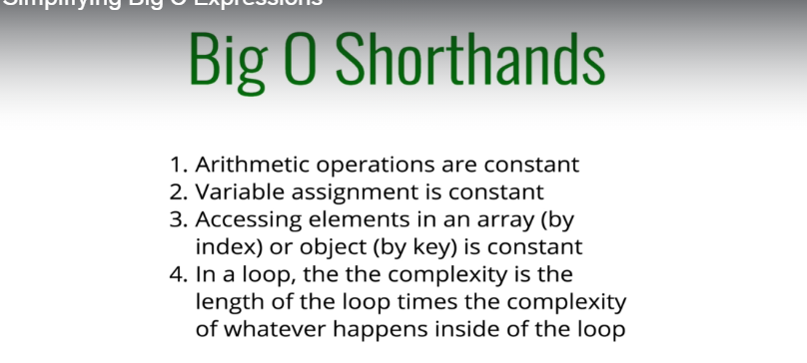

Space Complexity  
space required by algorithm(output)



